Name: **ZOHAIB HASSAN SOOMRO**

RollNo#: **19SW42**

Subject: **DBS**

Lab#2 Task In Lab#4 For Denormalization

Ex#1:

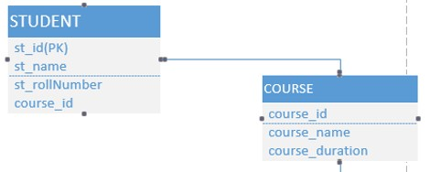

1. **Convert the above entities in tables, attributes into columns &**

**Ans:**

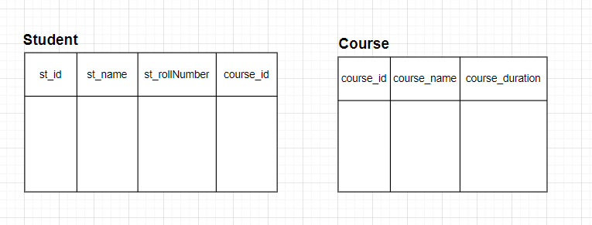

1. **also perform De-normalization.**

**Ans:**

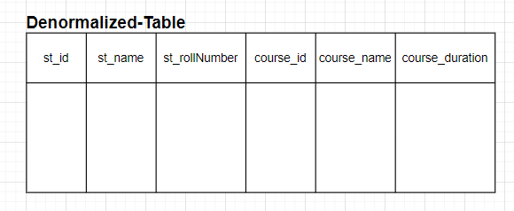

Ex#2:

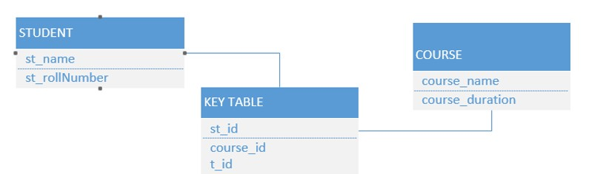

1. **Convert the above entities in tables, attributes into columns &**

**Ans:**

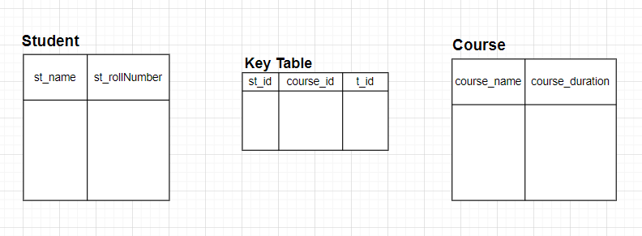

1. **also perform De-normalization.**

**Ans:**

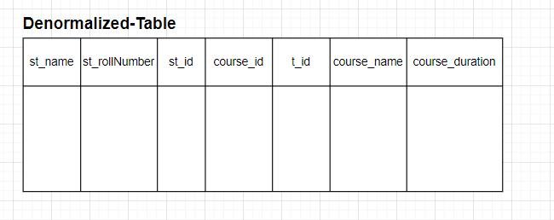

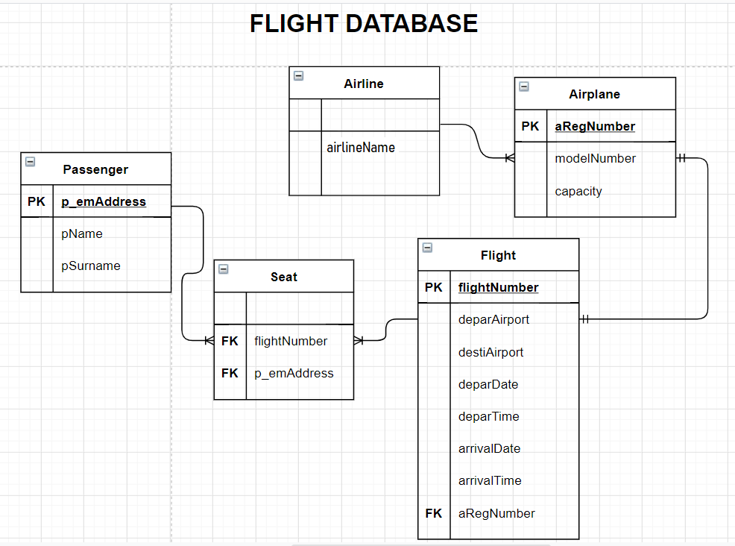

1. **Convert the above entities in tables, attributes into columns &**

**Ans:**

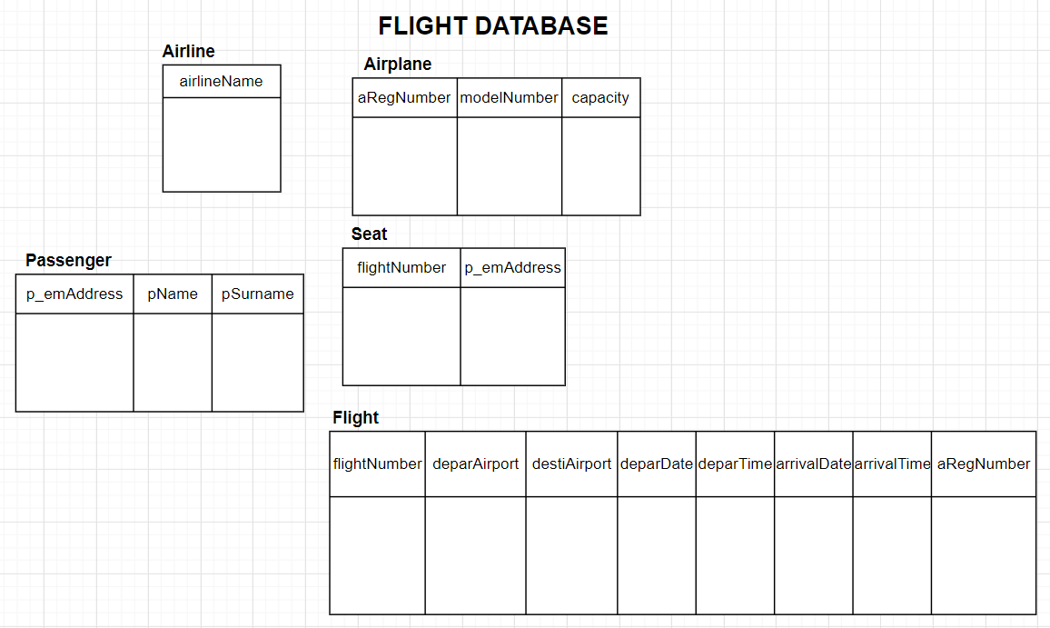

1. **also perform De-normalization.**

**Ans:**

